**PAWCARE: A user-friendly pet adoption website**

**Submitted By:**

* Megha Sherino (2460406): [megha.sherino@btech.christuniversity.in](mailto:megha.sherino@btech.christuniversity.in)
* Sanjana. N. Kothwal (2460443): [sanjana.n@btech.christuniversity.in](mailto:sanjana.n@btech.christuniversity.in)
* Tiya Arora (2460467): [tiya.arora@btech.christuniversity.in](mailto:tiya.arora@btech.christuniversity.in)

Course: UI/ UX Design Fundamentals

Instructor Name: Ms. Nagaveena

Institution: Christ University

Date of Submission: 13/ 08/ 2025

**Abstract**

PAWCARE, is a user friendly, responsive, pet adoption website designed to showcase adoptable pets from an animal shelter.

This project aims to organize pet profiles in an appealing card-based layout while enabling filtering options using only HTML and CSS. The website showcases different types of pets available for adoption, filtering options, volunteering process and testimonials. The focus was on a clean UI, responsive layout and visual hierarchy. Core technologies include HTML5 for structure, CSS3 (with Flexbox) for responsive design, and the CSS checkbox hack for basic interactivity. The website features sections such as Available Pets, Adoption Process, Success Stories, and a Volunteer Form, along with enhancements like pet personality tags, pastel color themes, and optional interactive elements.

The final outcome is an emotionally engaging interface that makes it easier for users to browse, filter, and learn about pets, ultimately promoting animal adoption and volunteer participation in a visually appealing and intuitive manner.

**Objectives**

The goals aimed to achieve in this project are:

1. Design a user-friendly interface using modern UI principles.
2. Develop a fully responsive layout using only HTML and CSS.
3. Implement structured HTML5 semantic elements.
4. Apply CSS styles for branding, layout and responsive behaviour.
5. Ensure accessibility and readability across devices.

**Scope of the Project**

This project focuses exclusively on front-end design for a pet adoption website. It is built entirely with HTML5 and CSS3, ensuring compatibility across desktop, tablet, and mobile viewports. No JavaScript or server-side integration is included, keeping the project strictly within the boundaries of static web design. The implementation uses only open-source tools and pure code, without relying on external libraries or frameworks. The primary emphasis is on creating an attractive, responsive, and accessible user interface that organizes pet profiles in a visually appealing manner, supports basic CSS-only interactivity, and delivers a smooth browsing experience for users on multiple devices.

**Limitations**

While the Pet Adoption Center Website successfully delivers a responsive and visually appealing interface, certain limitations exist due to its scope:

* **No JavaScript Functionality** – Advanced dynamic interactions, real-time updates, and animations beyond CSS capabilities are not implemented.
* **No Backend or Database** – The website does not store, retrieve, or process adoption data; all pet profiles are static.
* **Static Content** – Any updates to pet profiles or adoption information must be done manually in the HTML code.
* **No User Authentication** – The system does not include login or registration functionality for users or administrators.
* **Limited Interactivity** – Interaction is restricted to basic CSS-only features such as filters and selection highlights.

These constraints ensure the project remains lightweight and purely front-end focused while meeting its primary design goals.

**Tools and Technologies used**

|  |  |
| --- | --- |
| Tools and Technologies | Purpose |
| HTML5 | Markup and content structure |
| CSS3 | Styling and Layout Management |
| VS Code | Code Editor |
| Chrome Dev Tools | Testing and debugging |

**HTML Structure Overview**

1. <!DOCTYPE html>, <html>, <head> with title and stylesheet link
2. <meta name="viewport" content="width=device-width, initial-scale=1">: for proper mobile scaling.
3. Semantic elements:

* <header>: used for the site title
* div class="nav": contains icons and links
* Primary content is split into repeated <section id="..."> blocks:

1. filters: filter inputs (checkboxes).
2. #available-pet: the card grid of adoptable pets.
3. #adoption-process: ordered steps (<ol>/<li>).
4. #success-stories: explanatory section.
5. #volunteer-form: <form> with checkboxes and submit button.

* <footer>: social links and copyright
* Pet cards are div class="pet-card <type>" (e.g. pet-card dog, pet-card cat, pet-card hamster).
* Each card contains an <img> (with alt), <h3> for name, and <p class="tag"> for personality
* Navigation links use anchors like <a href="#available-pets">…</a>

**CSS Styling Strategy**

* Layout System: Flexbox
* { margin:0; padding:0; font-family: ... }: a simple reset.
* imported a Google Font using @import
* Sidebar nav: .nav { display:flex; flex-direction:column; align-items:center; position:fixed; width:150px; }: uses fixed sidebar + flex column layout.
* Card grid: .pet-container { display:flex; flex-wrap:wrap; justify-content:center; gap:1rem; padding:1rem; } — Flexbox grid with wrap and gap.
* Card sizing: .pet-card { width: 250px; padding:1rem; border-radius: 15px; } — fixed width per card gives a consistent card size
* Visual design: pastel palette, soft rounded corners, box-shadow is used on cards and images for soft elevation, and tag is styled with background color, white text, border-radius
* Hover effects for the nav and each .icon

**Key Features**

|  |  |
| --- | --- |
| Feature | Description |
| Responsive Design | Adapts seamlessly to all screen sizes |
| Smooth Navigation | Fixed top nav with anchor links |
| Project Cards | Flex- based layouts with hover effects |
| Contact Form (Non- Functional) | Placeholder layout for inputs and buttons |
| Accessible fonts and colours | Hing contrast and readability typography |

**Challenges Faced and Solutions**

|  |  |
| --- | --- |
| Challenge | Solution |
| Overlapping elements on small screen | Used media queries to stack elements |
| Difficulty aligning items using float | Shifted to flexbox |
| Typography scaling issues | Used relative units (em/ rem) instead of px |

**Outcomes**

* Achieved a clean, consistent, and visually engaging front end layout.
* All key components function as intended using just HTML and CSS.
* Learned about layout responsiveness and UI hierarchy in depth.

**Future Enhancements**

To expand the functionality and usability of the Pet Adoption Center Website, the following improvements can be implemented in future versions:

* **JavaScript Integration** – Add dynamic interactivity such as real-time filtering, animations, and interactive pet details popups.
* **Backend Development** – Implement server-side scripting with a database to store, update, and manage pet adoption data efficiently.
* **User Accounts & Authentication** – Allow users to register, log in, and save favorite pets for easy reference.
* **Online Adoption Application** – Enable users to submit adoption or volunteer forms directly through the website.
* **Search Functionality** – Add keyword-based search for quick access to specific pets or categories.
* **API Integration** – Connect with animal shelter databases to display live adoption data.
* **Accessibility Improvements** – Enhance ARIA roles, keyboard navigation, and high-contrast mode for inclusivity.

These additions would transform the website from a static informational portal into a fully functional, interactive adoption platform.

**Sample Code**

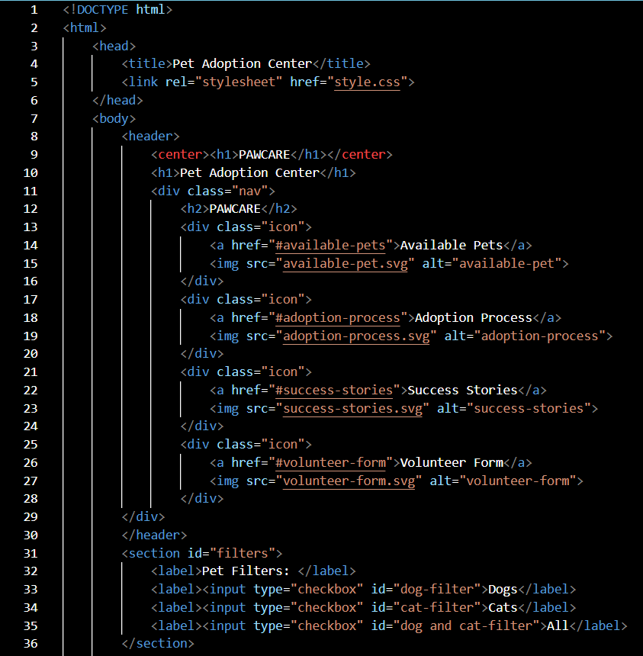

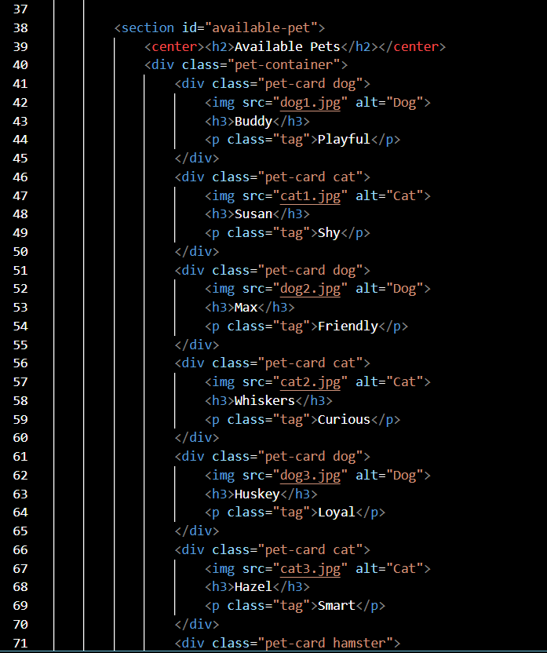

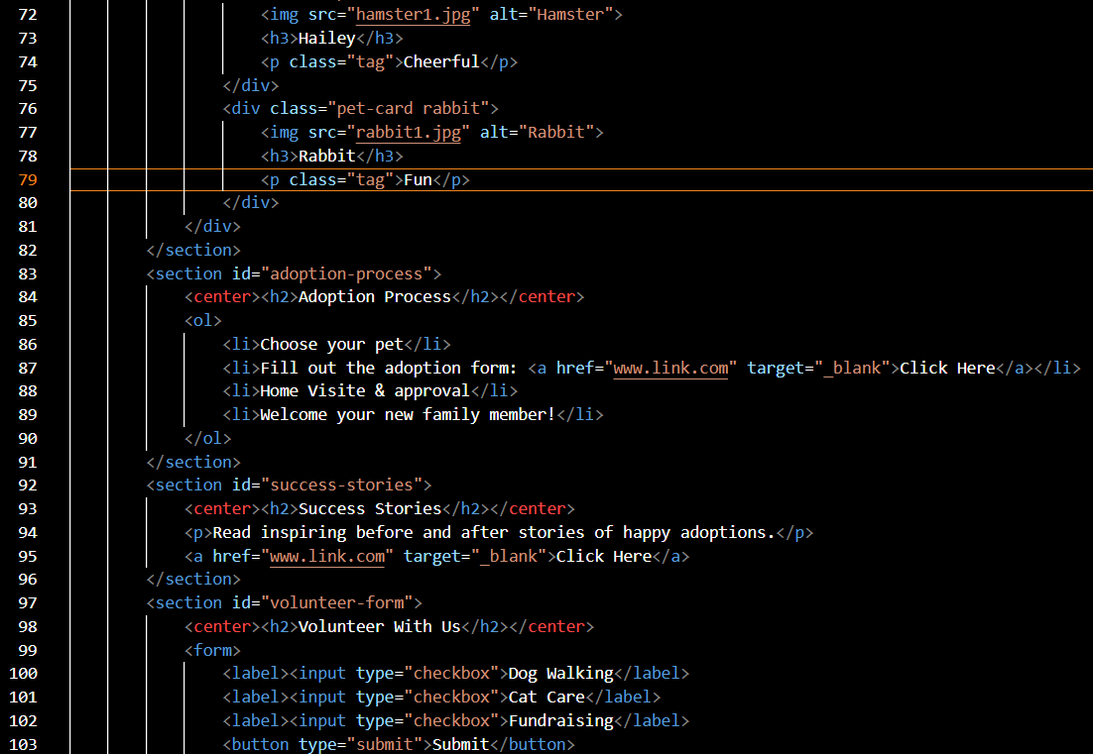

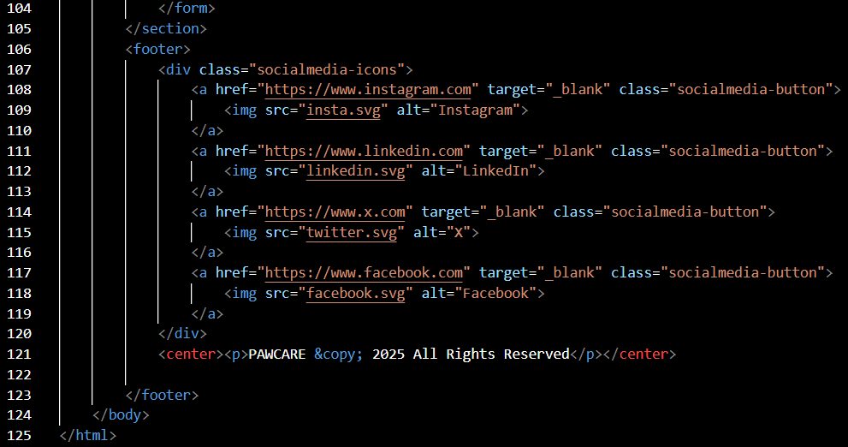

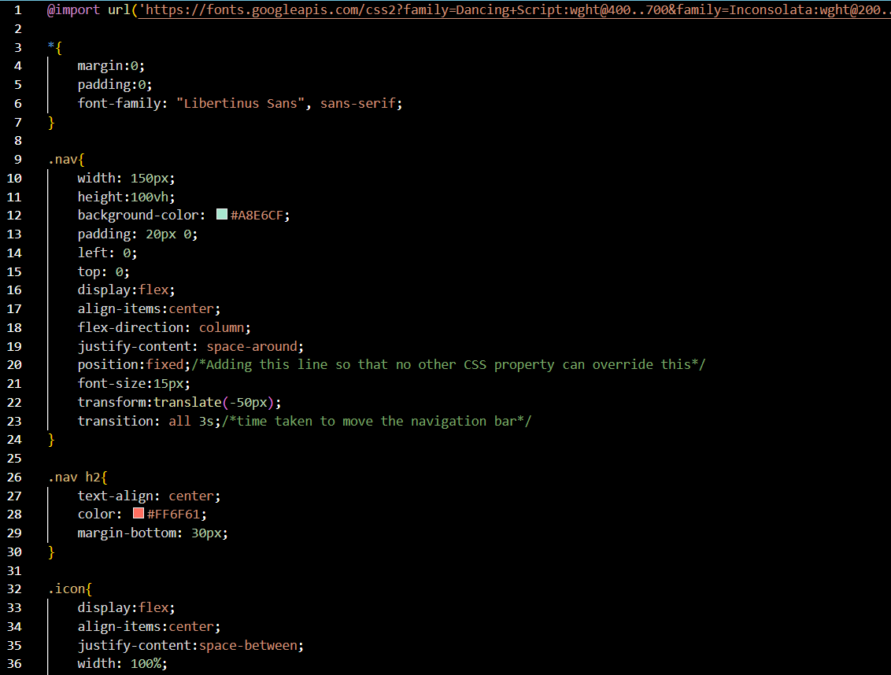

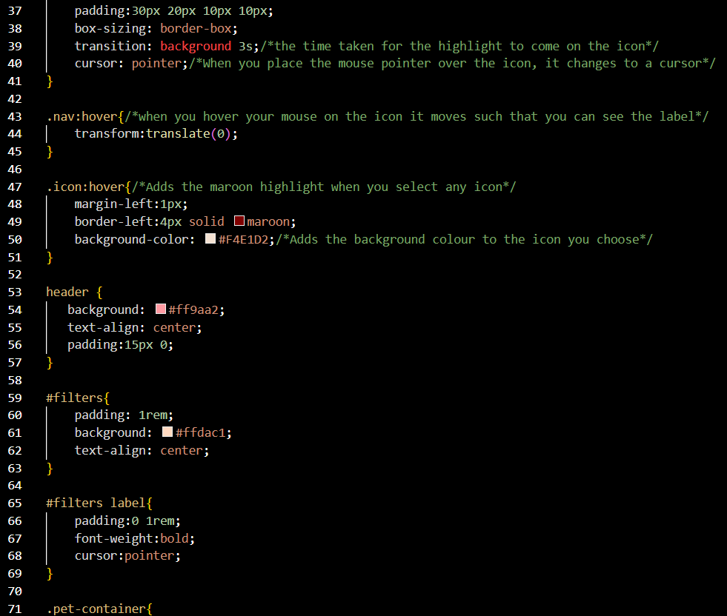

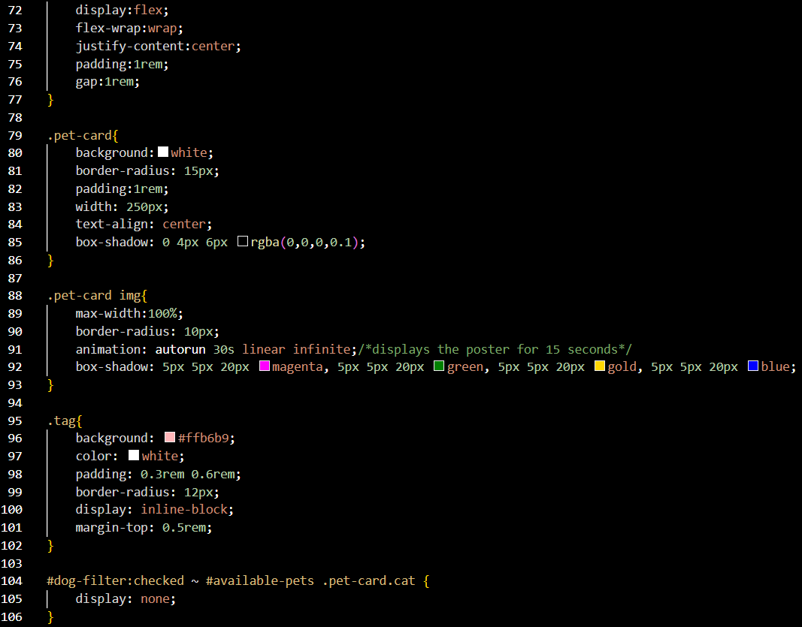

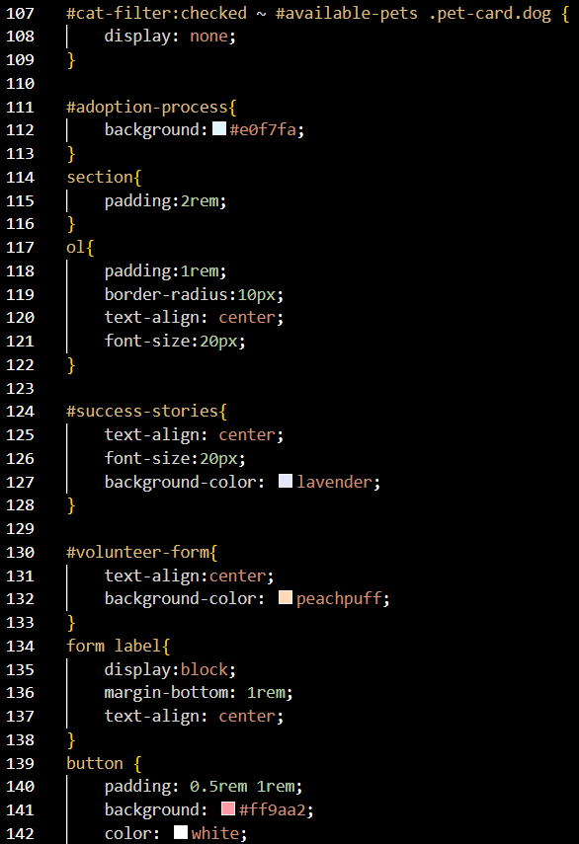

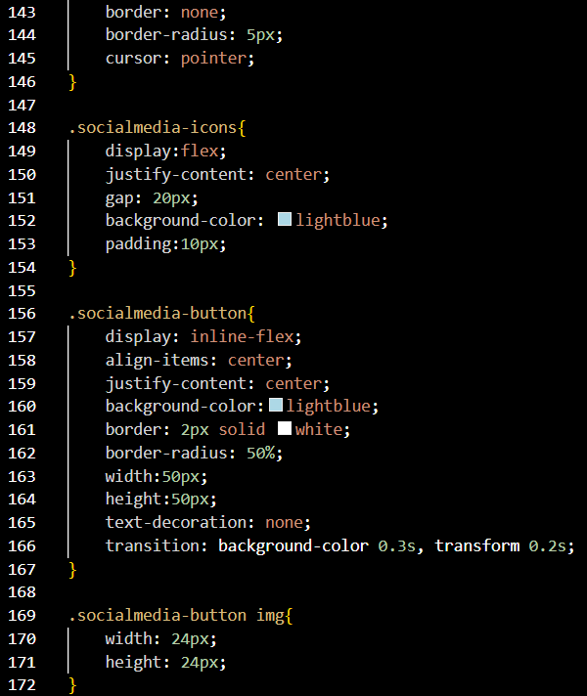

**Screenshots of final output**

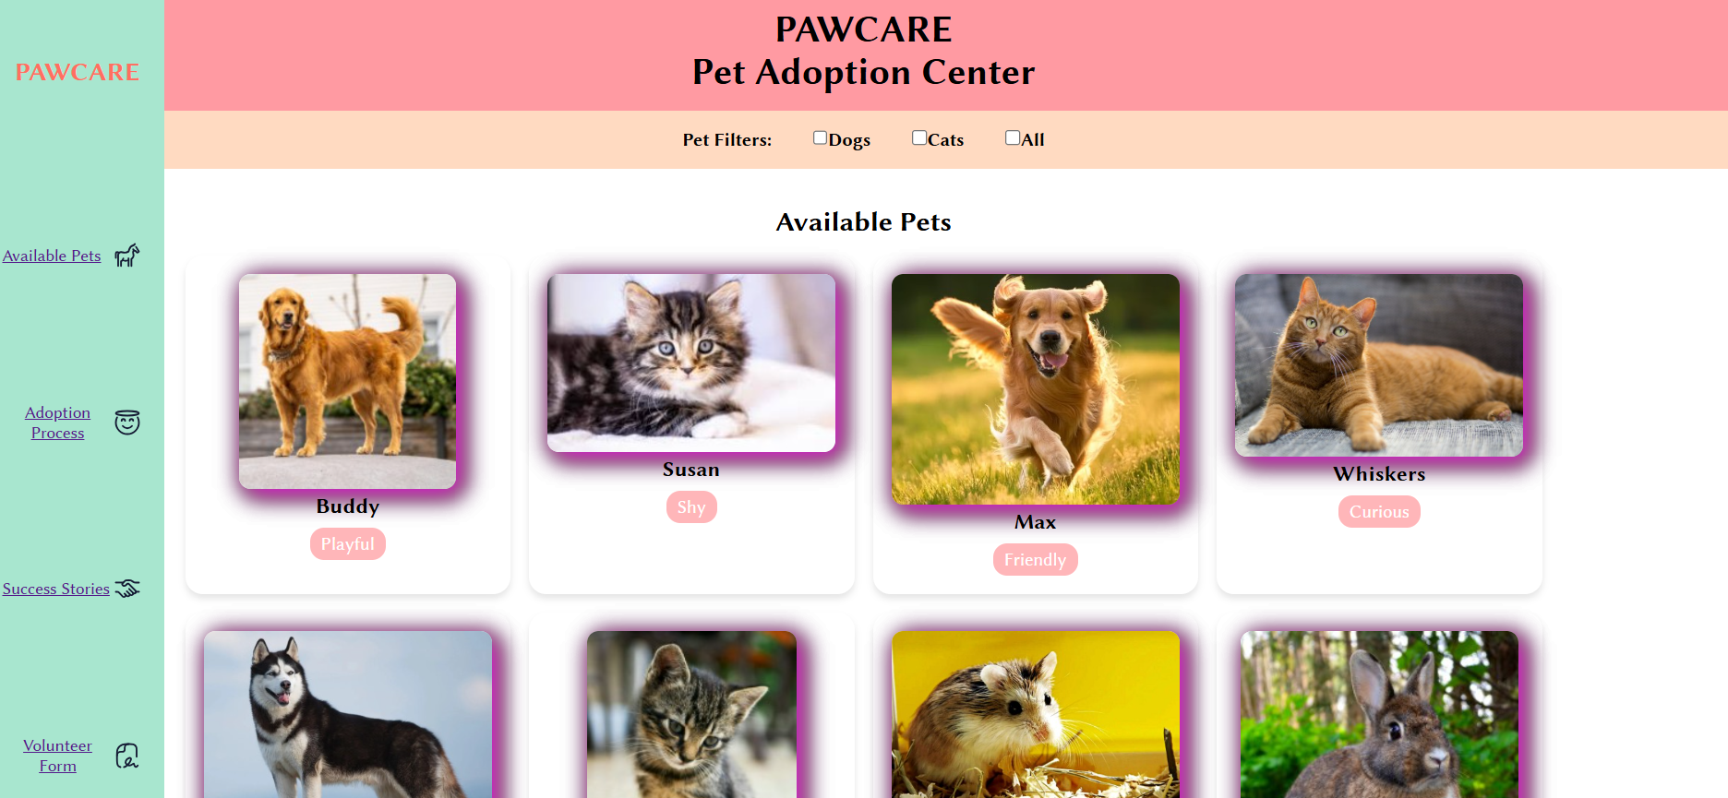

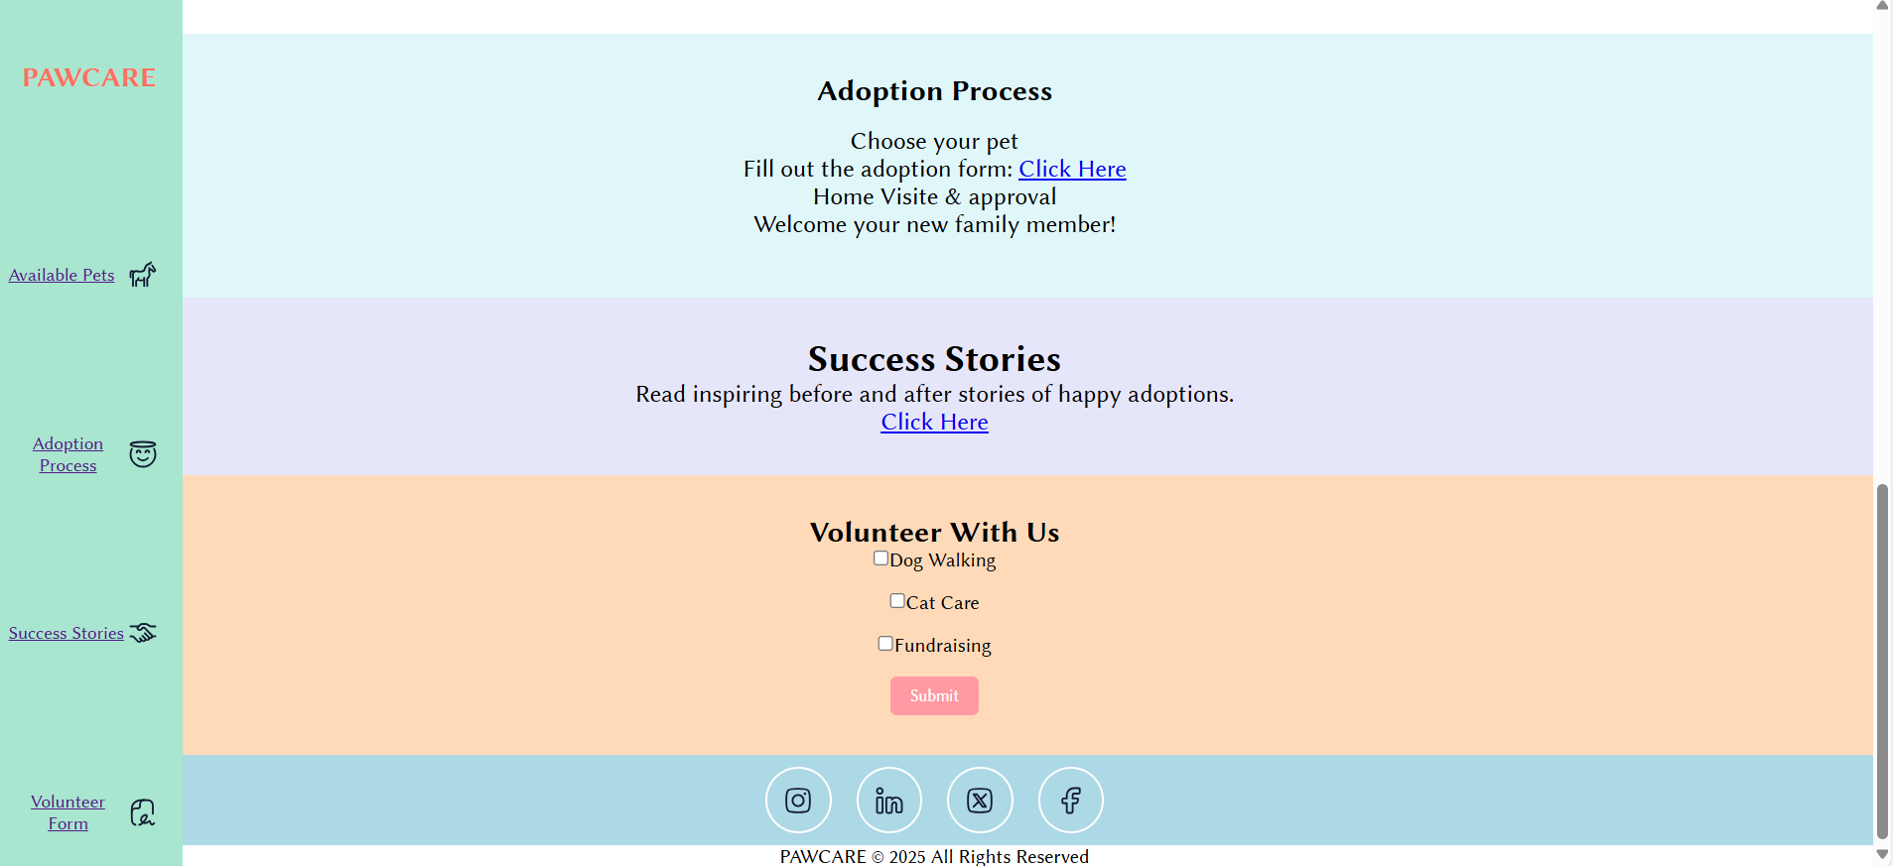

**Conclusion**

The development of this pet-themed website successfully demonstrates the effective integration of HTML and CSS to create a visually appealing, user-friendly, and well-structured digital interface. The HTML structure provides a semantic, organized foundation, ensuring that each section—navigation bar, content cards, and footer—is clearly defined and easy to navigate. The use of semantic tags not only enhances accessibility but also improves search engine optimization.

From a styling perspective, the CSS strategy focuses on balancing aesthetic appeal with functionality. A pastel-based color palette establishes a soft, welcoming atmosphere suitable for the pet theme, while strategic use of hover effects encourages interactivity without overwhelming the user. Flexbox layout techniques ensure responsive design, allowing the interface to adapt gracefully to different screen sizes and devices. The consistent use of padding, margins, and alignment creates visual harmony, while typography choices enhance readability and brand personality.

Overall, this project illustrates how thoughtful HTML structuring and deliberate CSS styling choices can transform a simple web page into an engaging, themed experience. Beyond the technical execution, the site reflects a deep understanding of design principles, responsiveness, and user engagement—key qualities in modern web development. This work serves as both a functional product and a learning milestone, showcasing the ability to translate design concepts into a polished, interactive web solution.